The Study of Calculus

Calculus is the fascinating study of the mathematics of change. This semester will be broken down into two main categories.
- Differential calculus (concerning slopes of curves and rates of change)
- Integral calculus (concerning the accumulation of various quantities and areas under curves)
It is instructive to begin with some example problems that fall into these categories.

Example 1: Consider two locations: Island A (near the north pole) and Island B (near the equator). Suppose that Island A is always F and Island B is always F. Suppose that Alice is on Island A and Bob is on Island B. Suppose that at 12:00 pm Alice takes a trip to Island B, and Bob takes a trip to Island A. Suppose that Alice arrives at Island B at 9:00 pm, and Bob arrives at Island A at 9:00 pm (assume there are no time zones for this problem and assume you know nothing about the route that Alice/Bob took). Must there have been a point in time in Alice’s and Bob’s trip when Alice and Bob were experiencing the exact same temperature?

Note: The above example is a differential calculus problem, and we will be able to prove whether the answer is yes or no by the end of chapter 2.

Example 2: The function is very important in the study of statistics. In fact, it is the basis for the student’s T-distribution. Therefore, it is important for the statistician to be able to answer questions like: What is the exact area under this curve as x varies from 1 to -1? A picture is below.
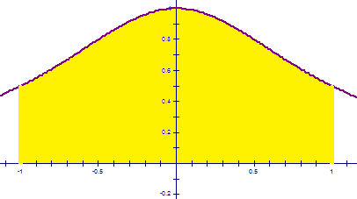

Note: This example is an integral calculus problem, and we will be able to solve it by the end of chapter 5.


Example 3: Suppose a hole has been punctured in the side of a barrel which contains some liquid. Suppose the liquid drains from the tank at a rate defined by a function . How much liquid will leak out of the tank within the first 30 minutes?

Note: This is another example of an integral calculus problem.

2.2 Limits (An Intuitive Approach)

Definition (Intuitive): Suppose is defined when x is near the number a. (This means that f is defined on some open interval that contains a, except possibly at a itself.) Then we write:

and say “the limit of , as x approaches a, equals L”

if we can make the values of (i.e., the y-values) “arbitrarily” close to L by taking x to be sufficiently close to a.

Notation:

Example 4: What do we expect the value of to be?

We can look at the graph and a table of values to see what this might be equal to.
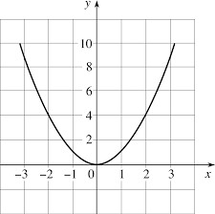

Table:
x | 1 | 1.5 | 1.9 | 1.99 | 1.999 | 2 | 2.001 | 2.01 | 2.1 | 2.5 | 3

Example 5:
Use the following graph to find the following values.
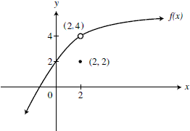

NOTE: When finding limits we are interested in what the function is approaching not what it is equal to at the value of a.

One Sided Limits

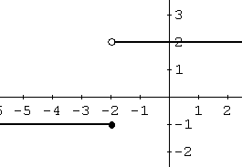
General Idea:
Consider the following function :

Find .

This question is difficult to answer. The graph seems to approach two different values as (depending on which direction/side we approach from).

Definition (Intuitive):
- We write

and say the limit of as x approaches a from the left is equal to L if we can make the values of
arbitrarily close to L by taking x to be sufficiently close to a and x less than a.

- Similarly we write

and say the limit of as x approaches a from the right is equal to L if we can make the values of
arbitrarily close to L by taking x to be sufficiently close to a and x greater than a.

Example 6:

Consider the following function :

Find the following:

NOTE: If a limit does not approach any one real number then we say that the limit “does not exist”.
DNE is short for “Does not exist”, and is a common abbreviation used in calculus.

This leads us to the following theorem

Theorem: Suppose that f is a function whose domain contains an open interval containing a with a possibly removed. Then, if and only if and .

Note: This theorem provides us with a way to prove that limits do not exist. In particular, if , we may conclude DNE.

Example 7:
Compute each of the following values for the graph of depicted to the right.
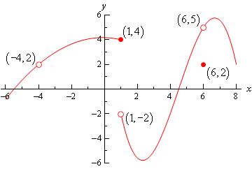

Infinite Limits
Exploration: Suppose that we are interested in finding .

Definition (Intuitive): If f increases without bound as x approaches a from both sides then we say

(Note the limit here does not exists)

Question: How would one need to change the intuitive definition above in order to give an intuitive definition of ?

Note: As we saw in the exploration, we can use the infinite limit idea for one sided limits as well.
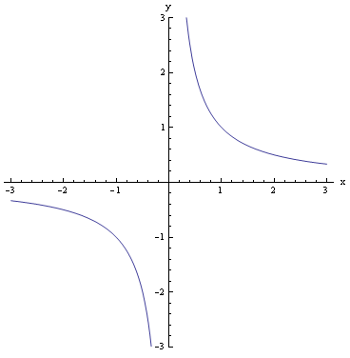
Example 8: Find each of the following limits.

